Title | Employee Attrition Prediction Using Workforce Indicators
Problem Statement | A company wants to analyze workforce behavior and predict employee attrition. Create a DataFrame containing OvertimeHours, JobSatisfactionScore, SalaryLevel, TrainingHours, WorkLifeBalance, YearsAtCompany, PromotionCount, and AttritionStatus. Create Log_OvertimeHours, categorize JobSatisfactionScore as Disengaged, Satisfied, or Highly Engaged, generate a correlation matrix, create a treemap visualization of employee categories, and analyze workforce trends to identify practical retention insights.
Objectives | • To create an employee workforce DataFrame from a predefined Python dictionary.  • To perform logarithmic transformation on employee overtime hours.  • To segment employees using job satisfaction scores.  • To encode attrition status for numerical analysis.  • To generate and interpret a correlation matrix of workforce indicators.  • To analyze attrition rates across employee engagement categories.  • To identify employees with high attrition risk using workforce conditions.  • To create a treemap visualization of employee categories.  • To derive retention insights related to workload, satisfaction, salary, training, promotion, and work-life balance.
Dataset  URL Link /  File | Predefined dictionary dataset used directly inside the Python program:  Table A: Overtime, Satisfaction, Salary and Training Indicators  Emp. Overtime Hours Job Satisfaction Score Salary Level Training Hours  1 5 5 5 40  2 12 4 4 35  3 18 3 3 28  4 26 2 2 16  5 8 4 4 34  6 32 1 1 10  7 15 3 3 24  8 28 2 2 18  9 10 5 5 45  10 24 2 4 30  11 35 1 1 8  12 6 4 4 38  13 20 3 3 26  14 34 3 2 12  15 38 2 2 14  Table B: Work-Life, Tenure, Promotion and Attrition Indicators  Emp. Work-Life Balance Years at Company Promotion Count Attrition Status  1 5 10 3 No  2 4 7 2 No  3 3 5 1 No  4 2 2 0 Yes  5 4 8 2 No  6 1 1 0 Yes  7 3 4 1 No  8 2 3 0 Yes  9 5 11 3 No  10 3 6 1 No  11 1 1 0 Yes  12 4 9 2 No  13 3 6 1 No  14 2 2 0 Yes  15 2 2 0 Yes  No external CSV file, URL, database, or online dataset is required.
Functions  Details | Sl. No. | Function | Package | Description of function
 | 1 | pd.DataFrame() | Pandas | Creates the workforce DataFrame from the predefined dictionary.
 | 2 | np.log() | NumPy | Calculates the natural logarithm of OvertimeHours.
 | 3 | pd.cut() | Pandas | Categorizes job satisfaction and attrition risk into defined groups.
 | 4 | map() | Pandas | Converts AttritionStatus values from Yes/No into 1/0.
 | 5 | corr() | Pandas | Generates the correlation matrix for numerical workforce indicators.
 | 6 | groupby() | Pandas | Groups employee records by engagement or attrition category.
 | 7 | agg() | Pandas | Calculates employee count, attrition count, averages, and summaries.
 | 8 | mean() | Pandas | Calculates overall attrition rate and average workforce indicators.
 | 9 | astype() | Pandas | Converts Boolean risk conditions into integer risk points.
 | 10 | value_counts() | Pandas | Counts employees within each attrition-risk category.
 | 11 | Rectangle() | Matplotlib | Creates proportional rectangles for the treemap visualization.
 | 12 | savefig()/show() | Matplotlib | Saves and displays the employee-category treemap.
Steps/  Process/  Procedure/  Algorithm/  Flowchart/  Model | Step 1: Import Pandas, NumPy, Matplotlib, and Rectangle from matplotlib.patches.  Step 2: Create the workforce dataset locally in dictionary format.  Step 3: Convert the dictionary into a DataFrame and assign employee numbers as the index.  Step 4: Create Log_OvertimeHours using the natural logarithm of OvertimeHours.  Step 5: Categorize JobSatisfactionScore as Disengaged, Satisfied, or Highly Engaged.  Step 6: Encode AttritionStatus as AttritionFlag using No = 0 and Yes = 1.  Step 7: Select numerical workforce indicators and generate the correlation matrix.  Step 8: Calculate the overall attrition rate and category-wise workforce summaries.  Step 9: Compare average workforce indicators for employees who stayed and employees who left.  Step 10: Create a rule-based risk score from overtime, satisfaction, salary, work-life balance, and promotion conditions.  Step 11: Create a black-background treemap showing employee-category size and attrition rate.  Step 12: Interpret workforce trends and recommend suitable employee-retention strategies.
Program | import pandas as pd  import numpy as np  import matplotlib.pyplot as plt  from matplotlib.patches import Rectangle  def print_heading(title):  print("\n" + "=" * 100)  print(title)  print("=" * 100)  # 1. Workforce dataset stored locally as a Python dictionary.  employee_data = {  "OvertimeHours": [5, 12, 18, 26, 8, 32, 15, 28, 10, 24, 35, 6, 20, 34, 38],  "JobSatisfactionScore": [5, 4, 3, 2, 4, 1, 3, 2, 5, 2, 1, 4, 3, 3, 2],  "SalaryLevel": [5, 4, 3, 2, 4, 1, 3, 2, 5, 4, 1, 4, 3, 2, 2],  "TrainingHours": [40, 35, 28, 16, 34, 10, 24, 18, 45, 30, 8, 38, 26, 12, 14],  "WorkLifeBalance": [5, 4, 3, 2, 4, 1, 3, 2, 5, 3, 1, 4, 3, 2, 2],  "YearsAtCompany": [10, 7, 5, 2, 8, 1, 4, 3, 11, 6, 1, 9, 6, 2, 2],  "PromotionCount": [3, 2, 1, 0, 2, 0, 1, 0, 3, 1, 0, 2, 1, 0, 0],  "AttritionStatus": [  "No", "No", "No", "Yes", "No", "Yes", "No", "Yes",  "No", "No", "Yes", "No", "No", "Yes", "Yes"  ]  }  # 2. Create and display the DataFrame.  df = pd.DataFrame(employee_data)  df.index = range(1, len(df) + 1)  df.index.name = "Employee"  print_heading("ORIGINAL WORKFORCE DATAFRAME")  print(df.to_string())  print("\nDataFrame Shape:", df.shape)  # 3. Feature engineering and workforce segmentation.  df["Log_OvertimeHours"] = np.log(df["OvertimeHours"]).round(3)  df["EmployeeCategory"] = pd.cut(  df["JobSatisfactionScore"],  bins=[0, 2, 3, 5],  labels=["Disengaged", "Satisfied", "Highly Engaged"],  include_lowest=True  )  df["AttritionFlag"] = df["AttritionStatus"].map({"No": 0, "Yes": 1})  print_heading("FEATURE ENGINEERING AND EMPLOYEE SEGMENTATION")  print(df[[  "OvertimeHours", "Log_OvertimeHours", "JobSatisfactionScore",  "EmployeeCategory", "AttritionStatus"  ]].to_string())  # 4. Correlation analysis.  numeric_columns = [  "OvertimeHours", "JobSatisfactionScore", "SalaryLevel",  "TrainingHours", "WorkLifeBalance", "YearsAtCompany",  "PromotionCount", "Log_OvertimeHours", "AttritionFlag"  ]  correlation_matrix = df[numeric_columns].corr()  print_heading("CORRELATION MATRIX")  print(correlation_matrix.round(3).to_string())  # 5. Workforce trend analysis.  overall_attrition_rate = df["AttritionFlag"].mean() * 100  category_summary = (  df.groupby("EmployeeCategory", observed=False)  .agg(  EmployeeCount=("AttritionFlag", "size"),  AttritionCount=("AttritionFlag", "sum"),  AverageOvertime=("OvertimeHours", "mean"),  AverageSalaryLevel=("SalaryLevel", "mean")  )  .reset_index()  )  category_summary["AttritionRatePercent"] = (  category_summary["AttritionCount"]  / category_summary["EmployeeCount"] * 100  ).round(2)  category_summary["AverageOvertime"] = category_summary["AverageOvertime"].round(2)  category_summary["AverageSalaryLevel"] = category_summary["AverageSalaryLevel"].round(2)  status_summary = df.groupby("AttritionStatus")[[  "OvertimeHours", "JobSatisfactionScore", "SalaryLevel",  "TrainingHours", "WorkLifeBalance", "YearsAtCompany",  "PromotionCount"  ]].mean().round(2)  print_heading("WORKFORCE TREND ANALYSIS")  print("Overall Attrition Rate: {:.2f}%".format(overall_attrition_rate))  print("\nEmployee Category Summary")  print(category_summary.to_string(index=False))  print("\nAverage Workforce Indicators by Attrition Status")  print(status_summary.to_string())  # 6. Rule-based attrition risk analysis.  df["RiskScore"] = (  (df["OvertimeHours"] >= 25).astype(int)  + (df["JobSatisfactionScore"] <= 2).astype(int)  + (df["SalaryLevel"] <= 2).astype(int)  + (df["WorkLifeBalance"] <= 2).astype(int)  + (df["PromotionCount"] == 0).astype(int)  )  df["AttritionRisk"] = pd.cut(  df["RiskScore"], bins=[-1, 1, 4, 5], labels=["Low", "Medium", "High"]  )  high_risk_employees = df[df["AttritionRisk"] == "High"][[  "OvertimeHours", "JobSatisfactionScore", "SalaryLevel",  "WorkLifeBalance", "PromotionCount", "RiskScore",  "AttritionRisk", "AttritionStatus"  ]]  print_heading("ATTRITION RISK ANALYSIS")  print("Risk Category Distribution")  print(df["AttritionRisk"].value_counts().sort_index().to_string())  print("\nHigh-Risk Employees")  print(high_risk_employees.to_string())  # 7. Treemap visualization using proportional Matplotlib rectangles.  total_employees = category_summary["EmployeeCount"].sum()  fig, ax = plt.subplots(figsize=(11, 6))  fig.patch.set_facecolor("black")  ax.set_facecolor("black")  x_position = 0.0  grayscale_colors = ["#2F2F2F", "#555555", "#7A7A7A"]  for index, row in category_summary.iterrows():  width = row["EmployeeCount"] / total_employees  ax.add_patch(Rectangle(  (x_position, 0), width, 1,  facecolor=grayscale_colors[index], edgecolor="white", linewidth=2  ))  label = (  f'{row["EmployeeCategory"]}\n'  f'Employees: {int(row["EmployeeCount"])}\n'  f'Attrition Rate: {row["AttritionRatePercent"]:.1f}%'  )  ax.text(  x_position + width / 2, 0.5, label,  color="white", ha="center", va="center",  fontsize=12, fontweight="bold"  )  x_position += width  ax.set_xlim(0, 1)  ax.set_ylim(0, 1)  ax.axis("off")  ax.set_title(  "Treemap of Employee Engagement Categories",  color="white", fontsize=16, fontweight="bold", pad=18  )  plt.tight_layout()  plt.savefig(  "hr_employee_category_treemap.png",  dpi=300, facecolor="black", bbox_inches="tight"  )  plt.show()  # 8. Final interpretation.  attrition_correlations = (  correlation_matrix["AttritionFlag"]  .drop("AttritionFlag")  .sort_values(ascending=False)  )  print_heading("FINAL WORKFORCE INSIGHTS")  print("Correlation of Workforce Indicators with Attrition")  print(attrition_correlations.round(3).to_string())  print("\nInterpretation:")  print(  "1. Higher overtime is associated with greater attrition risk.\n"  "2. Lower job satisfaction, salary level, work-life balance, training,\n"  " tenure, and promotion opportunities are associated with attrition.\n"  "3. Disengaged employees show the highest attrition rate.\n"  "4. Retention strategies should prioritize workload control, employee\n"  " engagement, career growth, training, and work-life balance."  )
Output Snapshots  With  Explanation/  Observations | Screenshot 1: Original Workforce DataFrame  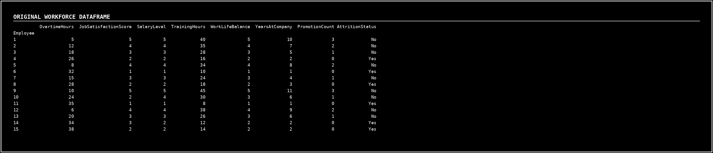  Figure 1.1 - Original Workforce DataFrame  Explanation/Observation: The locally defined dictionary was converted into a DataFrame containing 15 employee records and all eight required workforce indicators.  Screenshot 2: Feature Engineering and Employee Segmentation  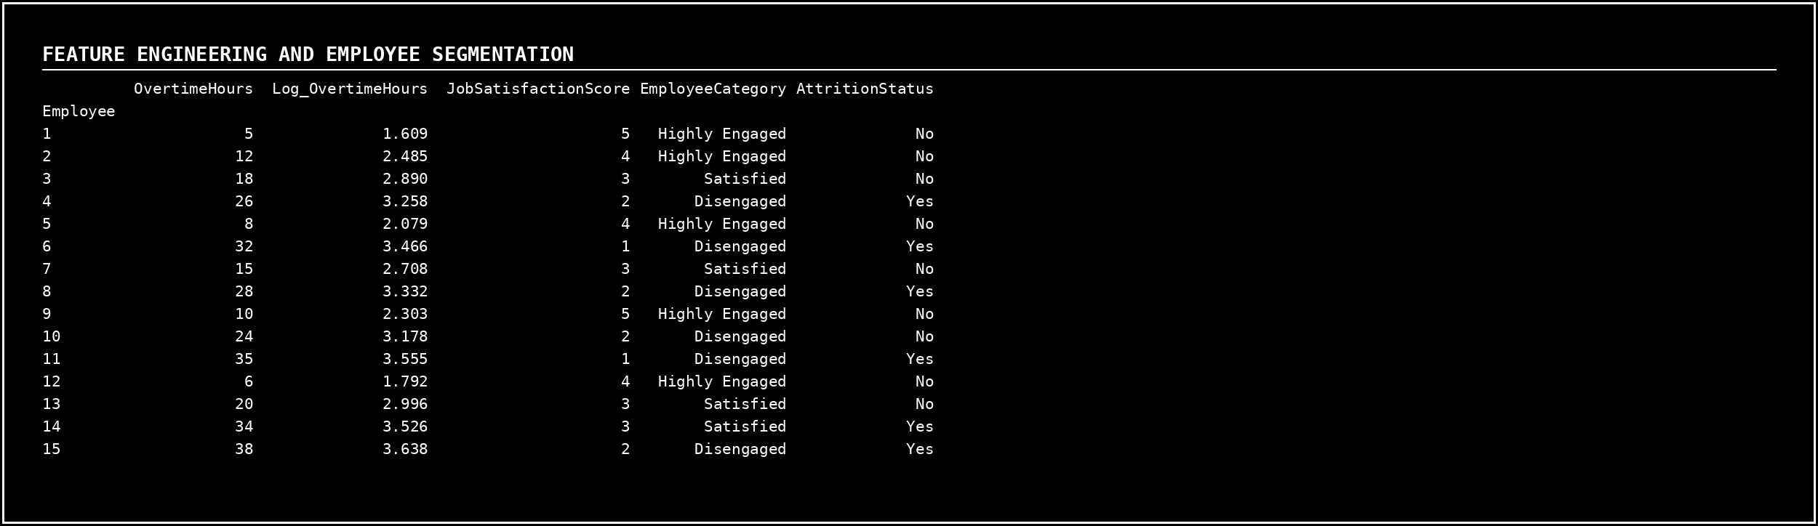  Figure 1.2 - Logarithmic Overtime Feature and Employee Categories  Explanation/Observation: Log_OvertimeHours was generated using np.log(). JobSatisfactionScore was categorized as Disengaged, Satisfied, or Highly Engaged, and AttritionStatus was retained for comparison.  Screenshot 3: Correlation Matrix  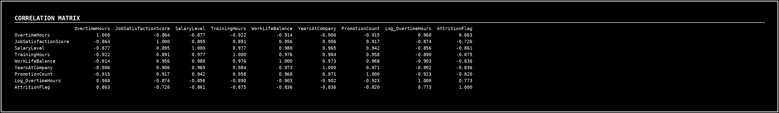  Figure 1.3 - Correlation Matrix of Workforce Indicators  Explanation/Observation: OvertimeHours has a strong positive relationship with attrition, while satisfaction, salary, training, work-life balance, tenure, and promotion indicators show negative relationships with attrition.  Screenshot 4: Workforce Trend Analysis  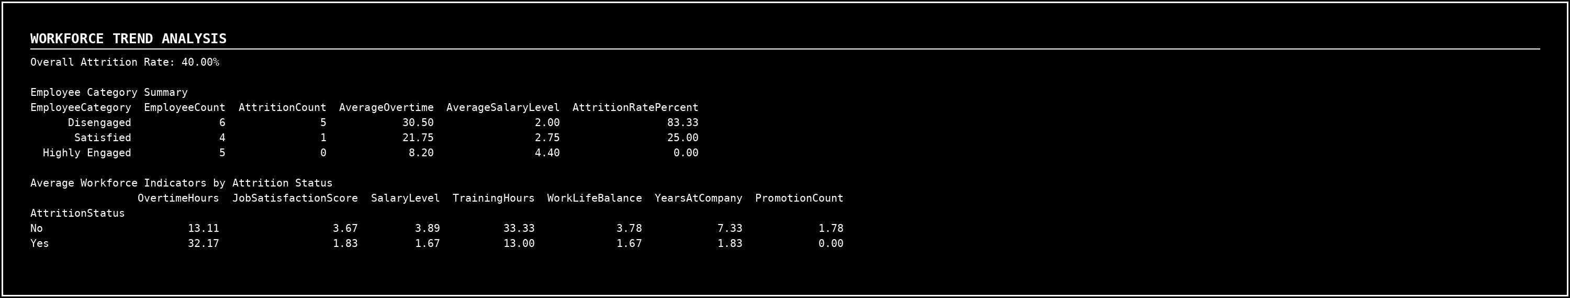  Figure 1.4 - Attrition Rate and Workforce Category Summary  Explanation/Observation: The overall attrition rate is 40%. Disengaged employees have the highest attrition rate and the highest average overtime, while highly engaged employees show no attrition in the sample.  Screenshot 5: Attrition Risk Analysis  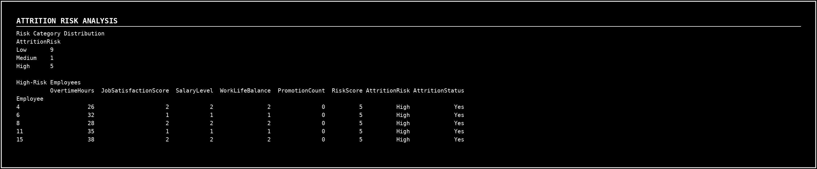  Figure 1.5 - Rule-Based Attrition Risk Distribution  Explanation/Observation: Employees were assigned risk points based on overtime, satisfaction, salary, work-life balance, and promotion conditions. Five employees were identified as high-risk, and all five have an observed attrition status of Yes.  Screenshot 6: Employee Category Treemap  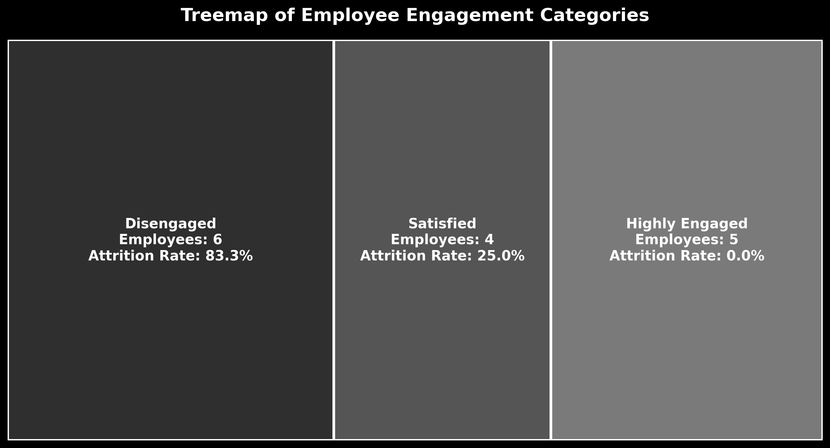  Figure 1.6 - Treemap of Employee Engagement Categories  Explanation/Observation: The treemap displays the relative size of each employee category. Each rectangle also reports the number of employees and the attrition rate for that category.  Screenshot 7: Final Workforce Insights  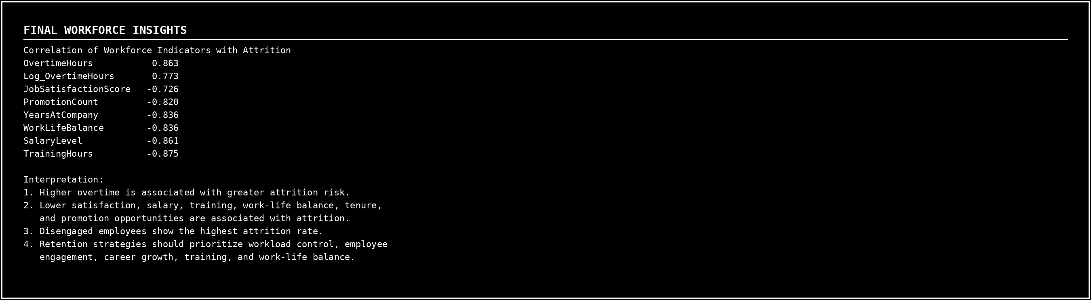  Figure 1.7 - Correlation-Based Workforce Interpretation  Explanation/Observation: The final analysis indicates that overtime is the strongest positive attrition indicator. Retention efforts should focus on workload control, engagement, compensation, training, career growth, and work-life balance.
Conclusions | The Human Resource Analytics exercise was completed successfully using Pandas, NumPy, and Matplotlib. A workforce DataFrame was created from a predefined Python dictionary, Log_OvertimeHours was generated, and employees were segmented using job satisfaction scores. The correlation matrix showed that higher overtime was positively associated with attrition, whereas job satisfaction, salary level, training, work-life balance, tenure, and promotion opportunities were negatively associated with attrition. The treemap highlighted the distribution of engagement categories, and the trend analysis showed that disengaged employees had the highest attrition rate. The rule-based risk analysis identified employees requiring immediate attention. These findings support retention strategies focused on workload reduction, employee engagement, fair compensation, career progression, training opportunities, and improved work-life balance.
References | 1. Michael Freeman and Joel Ross, Programming Skills for Data Science: Start Writing Code to Wrangle, Analyze, and Visualize Data with R, Addison-Wesley, 2018.  2. Pandas documentation for DataFrame creation, categorization, grouping, aggregation, mapping, and correlation analysis.  3. NumPy documentation for logarithmic transformation.  4. Matplotlib documentation for figures, rectangles, text, and image export.  5. Python program supplied with this exercise: Exercise_Program_10_HR_Attrition_Analytics.py.  6. Programming for Data Science (MACSE502) class lecture notes

